


Submitted To
4iapps.com
Future Design Document – Oracle Custom Time and Attendance – Internal Team
DOCUMENTATION FOR

Table of Contents:
1. Document Control 3
1.1 Change Record 3
1.2 Reviewers 3
1.3 Approvers 3
2. Introduction 4
Purpose 4
Scope 4
Bio-Metric Data 4
3. PROCESS FLOW DIAGRAM - LEGENDS 5
4. Processes 6
Attendance Process 6
Ramadan Calendar 8
Work Shift Creation 9
Shift Master 10
Shift Upload 12
Shift Update 14
Employee Attendance 16
Line Manager Attendance 18
HR Attendance 20
5. Employee Request 22
Justification 22
Change Time Request 24
Feeding Hour Request 26
Overtime Request 28
6. Raw Data 30
7. Integration Process 31
8. Employee Exception 32
9. Attendance Exception 33
10. Employee Punch In & Out 34
11. Manager Proxy 34
12. GeoFencing Admin Page 35
13. Shift Details for Regular Employees 35
14. Event Request Page - OCEC Entity 36
16. Shift Upload – Casual Staff - OCEC Entity 37
17. Casual Staff – Time Card Submission - OCEC Entity 39

Document Control
  - Change Record
Date | Author | Version | Change Reference
30-Oct-2024 | Parthasarathy Peruru | Initial Version
24-Nov-2024 | Parthasarathy Peruru | 1.1 | Add new column in attendance calculation  Regular employee shift details (Topic 13)  Included OCEC requirement pages and approvals (14, 16,17)

  - Reviewers
Name | Position
Mr. Shagul Hameed | Project Manager

  - Approvers
Name | Position | Signature

Introduction

Purpose
Oracle Custom Time and attendance application is a comprehensive, easy to use, rule-based time calculating and management system. The Architecture is designed to give the organizations maximum visibility, control, and flexibility over the resources.

Oracle Custom Time and attendance application enables simplified Shift and monthly scheduling for managers and administrators. A simplified end user functionality for viewing work timing with flexible update option. Application also provides a wide scope for Line Managers to handle shift, schedules, and attendance for the team member.

Human Resources / Administrators have a much wider usage functions like tracking attendance and absenteeism shall be deep dived this shall help in effective resource planning for seamless business deliver in their core areas

Scope
This document covers Business flow diagrams and Future business process of following Processes.
- Create Work Shifts
- Shift Upload
- Shift Update
- Inflow of Biometric Data (Integration of data)
- Change Time Request
- Overtime Request
- Employee & Line Manager Attendance
- Reporting
- Payroll Integration

Bio-Metric Data
Employee attendance data is collected from bio metric database to oracle database on frequently interval and this raw data is processed and displayed to employee, Line Manager & HR.

PROCESS FLOW DIAGRAM - LEGENDS
Legend Introduction
Symbol | Description | Symbol | Description
 | Manual Operation |  | Oracle System Process
 | Process Flow |  | Document in hard copy such as report, form, etc. and Notifications.
 | Decision |  | Predefined Oracle System Sub Process
 | Manual Input |  | Stored Data
 | Connector |  | Terminator

Processes

Attendance Process
Employee attendance is processed on daily basis for the previous day and the notification will be sent to employee if there is any exception (Late, Missed Hours, Missing In/Out, Absent). So the employee shall raise the justification request or Apply Leave. Below are the column to be calculated and stored in backend.
Column | Logic
Employee Number
Legal Entity
Bio Metric Number
Person ID
Employee Name
Attendance Date | Date
Shift Code | Assigned Shift Code, for OCEC employees, sometimes regular employees works in shift and the shift will be uploaded.
Shift Start Time | Assigned Shift Start Time
Shift End Time | Assigned Shift End Time
Shift Start Time 2 | Assigned Shift Start Time 2
Shift End Time 2 | Assigned Shift End Time 2
Day | Shift Day (Sunday / Monday etc)
Actual In | Check In time, first punch, Check range from 2 hours before the shift start time
Actual Out | Check out time, Last Punch for Non-Shift employees, check time range until, after 4 hours from the shift end time for shift based employees
In Time | Shift start time or actual In (If its later to shift In time), For Oman sail, In time can be before 30 Min.
Out Time | Calculated Out Time
In Time 2 | Split shift - In time 2
Out Time 2 | Split shift - Out time 2
Late Hours | Late should be calculated based on the flexi hours and late exception minutes mentioned in the Shift master for the particular shift. No Late policy for Oman sail.
Missed Hours | Show the hours, If total worked hours is less than Shift Duration (Should be calculated based on In Time & Out Time, not based on Actual In & Out). For Oman sail, Any time less than 5 Hous.
Extra Hours | Any hours more than his total shift hours.
Total Hours | Total hours employee worked, based on In time & Out time
Normal Overtime Hours | Overtime should not be calculated if the employee is not eligible fot Overtime  Normal Overtime - 6 AM to 9 PM - ((Basic Salary / Work hours in the month) * number of hours worked) *1.5  Night Overtime - 9 PM to 6 AM - ((Basic Salary / Work hours in the month) * number of hours worked) *1.75  Weekends/ Holidays - ((Basic Salary / Work hours in the month) * number of hours worked) *2
Night Overtime Hours
Holiday Overtime Hours | Employee working on Off Shift, Rest Shift or on holiday calendar, Maximum 12 Hours
Absence Details | If there is absence record for particular day, show the absence name
Exception / Status | Regular - If employee has In & out time without any below exceptions  Late In - If employee has Late Hours  Missed Hours - If employee has Missed Hours  Missing In/Out - If employee does not have In or Out Time  Absent - If In time & Out time both are missing and no leave record for attendance date  Leave - If employee has any approved leave for attendance date  Off - If shift is assigned as Off.  Shift Missing - When no shift is assigned for shift employee, when no shift assigned for regular employee .
Notification | Exception (Late, Missed Hours, Missing In/Out, Absent) notification has to be sent employee on daily basis.
Automatic Reprocess | If the employee attendance status is Absent or Missing In/Out, system has to check whether the leave is applied for those days and the status has to change to Leave from Absent. This can be checked for last 90 days of attendance
Shift consideration | If its shift employee, check the shift from shift update table and secondly from shift upload table
 | If its regular employee, check the shift from shift update, shift uplaod, If no values in these two, take from Regular shift table

Employee Number & Category Mapping
As the employee number in the bio metric system is different from the number assigned in oracle, there will be one time activity that existing employee number that is assigned in bio metric will be collected from HR team and map the number in Oracle in Person DFF in segment “Bio Metric Number”.

Ramadan Calendar
HR will update the Ramadan calendar by entering Year, Start Date & End Date for the particular year and attendance calculation will be processed accordingly. All Muslim regular shift employees will work for 6 Hours Duration during Ramadan.

This is common page where any one person enter the details the same will be used for all the OMRAN group entities

Below are fields to be entered while creating the shift
- Year
- Ramadan Start Date
- Ramadan End Date
- Hours

Prompt | Field Type | Condition / Values
Year | LOV | 2024, 2025, … 2040
Start Date | Calendar
End Date | Calendar
Hours | HH:MM

Design

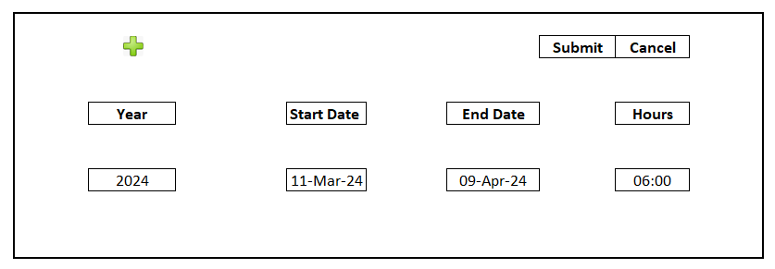

Conditions | Only one record should be there for each year
 | Develop as separate page so end user will decide who will have this page access

Work Shift Creation
Work Shift is a specific period, typically expressed in hours. This can be defined by a start / end time and duration.
Ex: Regular Shift Employee: Shift starts from 08:00 AM to 05:00 PM and duration is 9 Hours, these employees work in flexi shift of 1 hour.
Ex: for Shift Employees: Shifts will be uploaded by line managers
Late Policy must be defined while creating the shift, Early Out policy must be defined while creating the shift, and employee has to complete his/her full shift duration.
Below are fields to be entered while creating the shift
Design
 |  |  |  | Save | Submit
 | Prompt | Field Type | Condition / Values
 | Shift Code | Free Text | Value should be Unique Entity Wise
 | Shift Name | Free Text | Value should be Unique Entity Wise
 | Shift Type | LOV | Split, Non-Split
 | Flexi Hours | LOV | 0 Min, 30 Min, 60 Min, 90 Min
 | Late Exemption | LOV | 0 min, 5 Min, 10 Min, 15 Min, 20 Min
 | Early Out Exemption | LOV | 0 min, 5 Min, 10 Min, 15 Min, 20 Min
 | Legal Entity | LOV | Should show the Legal entity as per employee access
 | Consider OT After | LOV | 30 Min, 60 Min, 90 Min, Not Applicable
 | Shift Start Time | Time | Mandatory
 | Shift End Time | Time | Mandatory
 | Duration | Calculate Automatically
 | End Date | Date | To update the end date, so the particular shift will be inactive
 | Add

Conditions | Duration should be calculated based on Shift Start Time & End Date
 | Add button should be enabled only if the shift type is selected as Split

Shift Master
Shift master will list out all the shifts that is created by HR, and Line Manager shall refer the shift master to assign the shift for the employees.

Below are the search fields available for Line Manager or HR to search the shift

- Legal Entity*
- Shift Code
- Shift Name
- Category
- Start Time
- End Time
- Duration

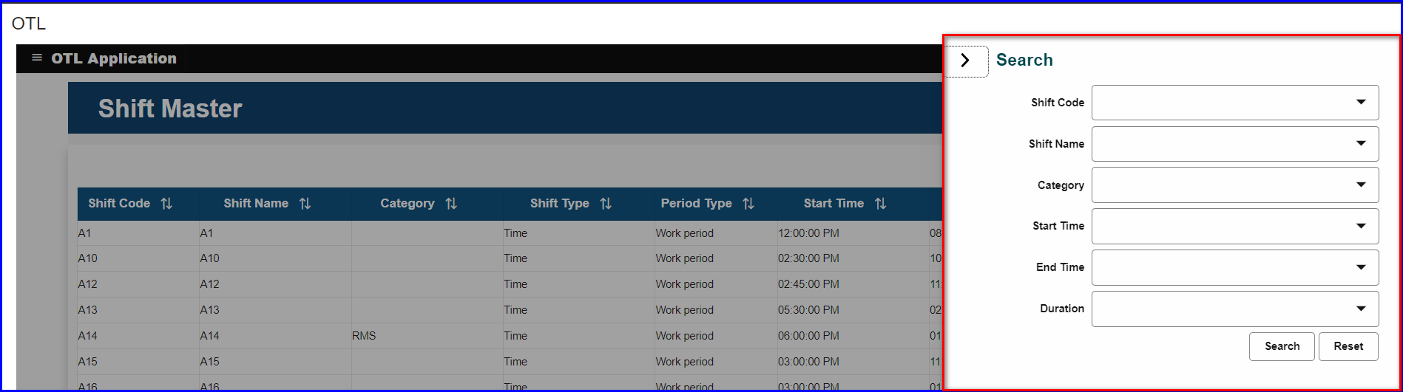
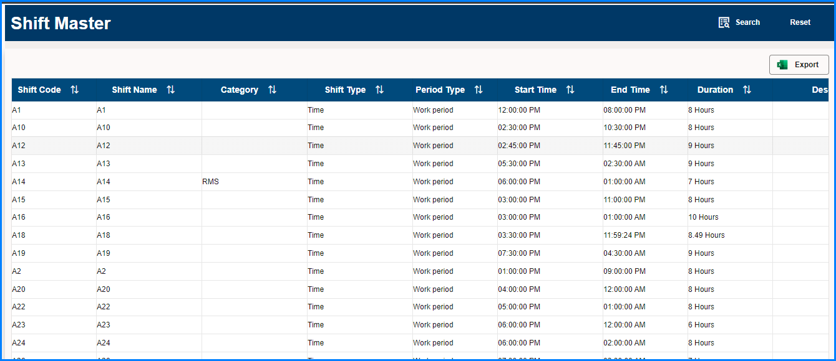

Conditions | Additionally Legal Entity should be field should be display and it should be defaulted to logged In Employee Legal Employee and this field should be mandatory
 | Should have option to update shift details for each line

Shift Upload
Employee Category (Shift Employee / Regular Employee) will be captured employee wise at employment screen

Shift upload option can be done only for shift employees.

Shift schedule (Roaster) has to be uploaded by Line Manager / HR for shift-based employees.

For Regular-based employees, Regular shift & OFF will be assigned.

Shift Upload option will be available for Line Managers to upload the shift for each day for all his/her subordinates for shift-based employees on weekly or monthly wise. This process is mandatory, attendance will be calculated on daily basis based on the shift that is uploaded. If shift is not available, employee attendance status will be shown as “Shift Unavailable”. Shift has to be assigned before the attendance date. Line Manager has to select the below values and upload the schedule prepared in the given template.

- Shift Year
- Shift Month

Line Manager can upload the shift for their subordinates who are shift based category.
HR can upload the shift for any of the shift-based employee in the organization
Proxy Line Manager can upload the shift for their subordinates

Design

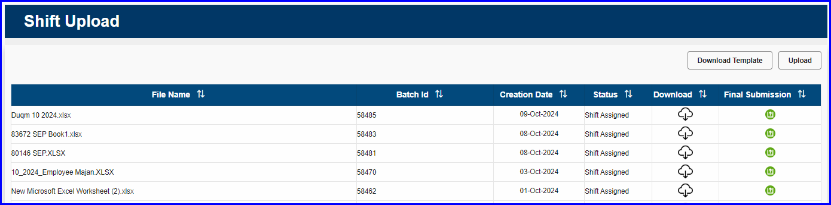

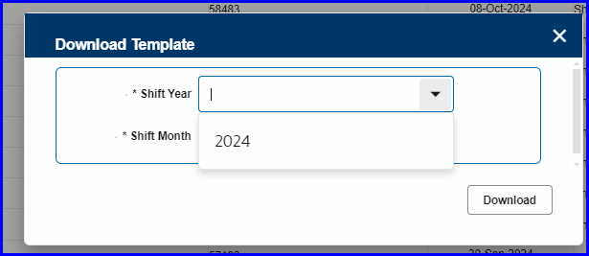

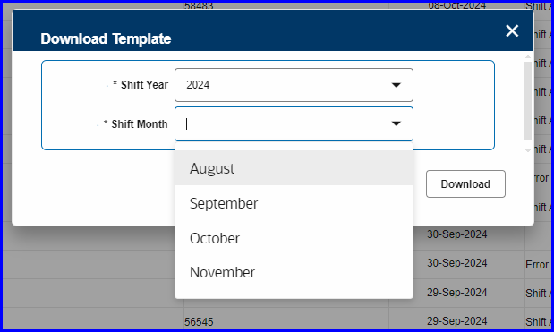

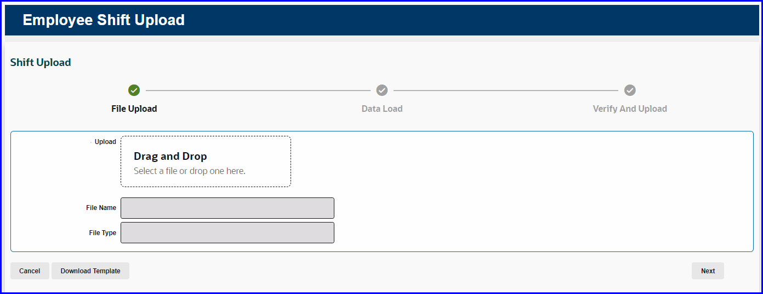

Conditions | Line Manager can upload shift only for his employee
 | HR Can upload shift for any employee for Legal Entity where he have access (Area of Responsibility
 | Proxy Line Manager can upload the shift for their subordinates

Shift Update
If there is a scenario that line manager wants to change the schedule of an employee for a particular day or the shift needs to be swapped among two employees. Line Manager & HR shall have an option to search the employee and update the uploaded shift for an particular date. This activity should be done before the attendance is processed. Below are the parameters available to search and update the shift.

- Employee
- Period

This option is only available for shift-based employees
Design
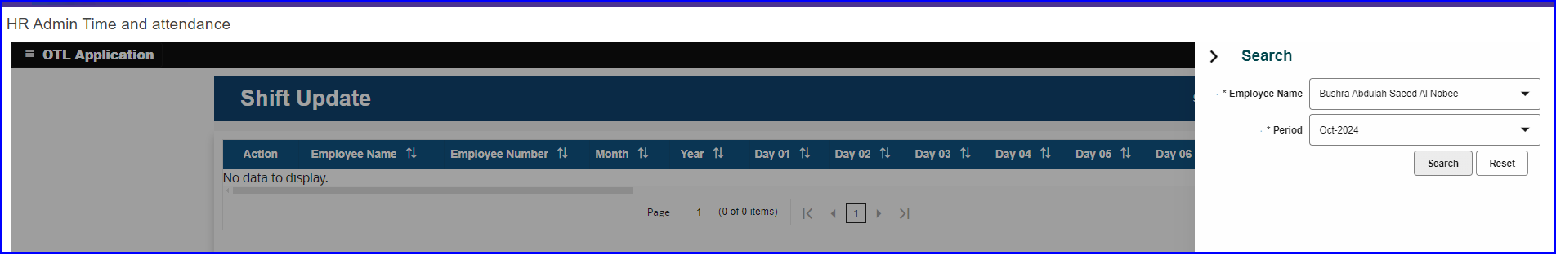
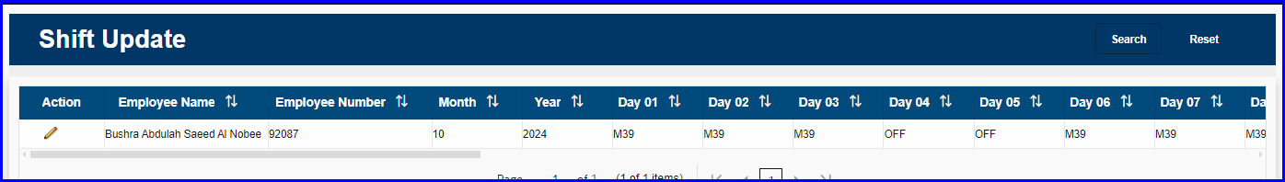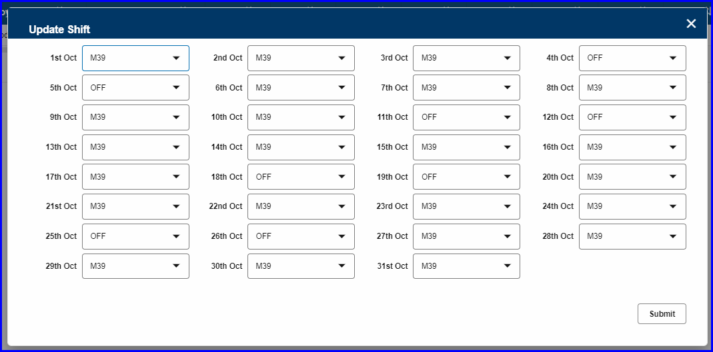

Conditions | Line Manager can update shift only for his employee
 | HR Can update shift for any employee for Legal Entity where he have access (Area of Responsibility
 | Proxy Line Manager can update the shift for their subordinates

Employee Attendance
Employee will be able to view the daily attendance details from there login. Below details will be displayed and attendance details will be available to view till previous date. Employee should have option to view on the day attendance.

Attendance Date | Displays the attendance date
Shift Code | Displays the Shift code for an particular attendance date that is assigned by Line manager for shift based employee, and regular shift for regular based employee.
Shift Start Time | Displays the Shift Start Time for the assigned shift
Shift End Time | Displays the Shift End Time for the assigned shift
Timecard Status | Displays the Timecard Status as  Regular – If employee does not have any exceptions.  Late/Early – If the employee has Late hours or Missing hours  Absent – If the employee has no punch details for the particular attendance date and not applied leave for that date.  Missing In/Out – If the employee has either Punch In or Punch Out for the attendance Date  Leave – If employee have applied leave for the day  OFF – If the shift is assigned as OFF or if its Friday or Saturday for regular shift employees
Leave Detail | Leave type will be displayed if the approved leave is available
Actual In | Actual In Time displayed, if the employee Punch In earlier than Shift Start Time.
Actual Out | Actual Out Time displayed
In Time | Display the In time of an employee
Out Time | Display the Out time of an employee
Total Hours | Shows total Hours that is calculated between In Time & Out Time.
Early Out Hours | Early out is calculated and displayed, If employee works less than assigned shift duration
Late Hours | Late hours is calculated and displayed, If employee Punch In more than Leverage Min mentioned in Shift
Extra Hours | Extra hours is calculated and displayed, any time employee worked more than the assign shift duration.

Design
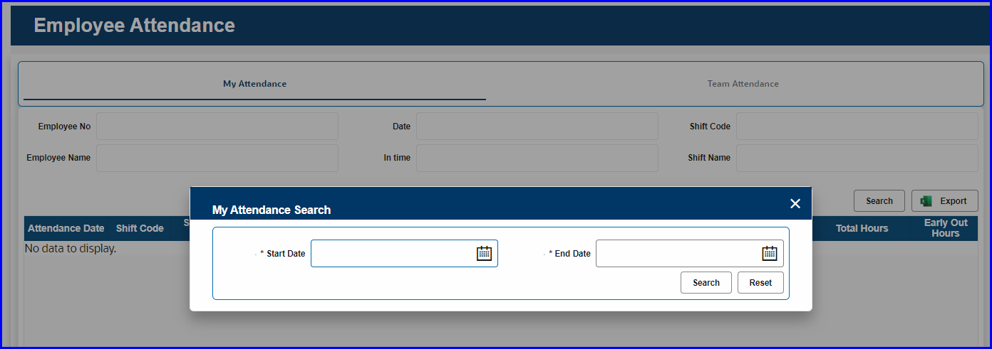
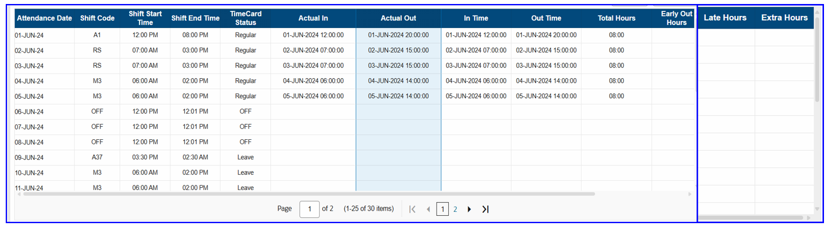

Line Manager Attendance
Line Manager & Proxy Line Manager will be able to view their subordinate’s daily attendance details from there login. Below details will be displayed and attendance details will be available to view till previous date.

Below are the Search Option available

- Employee (List should show only their Subordinates)
- Start Date
- End Date

Attendance Date | Displays the attendance date
Shift Code | Displays the Shift code for an particular attendance date that is assigned by Line manager for shift based employee, and regular shift for regular based employee.
Shift Start Time | Displays the Shift Start Time for the assigned shift
Shift End Time | Displays the Shift End Time for the assigned shift
Timecard Status | Displays the Timecard Status as  Regular – If employee does not have any exceptions.  Late/Early – If the employee has Late hours or Missing hours  Absent – If the employee has no punch details for the particular attendance date and not applied leave for that date.  Missing In/Out – If the employee has either Punch In or Punch Out for the attendance Date  Leave – If employee have applied leave for the day  OFF – If the shift is assigned as OFF or if its Friday or Saturday for regular shift employees
Leave Detail | Leave type will be displayed if the approved leave is available
Actual In | Actual In Time displayed, if the employee Punch In earlier than Shift Start Time.
Actual Out | Actual Out Time displayed
In Time | Display the In time of an employee
Out Time | Display the Out time of an employee
Total Hours | Shows total Hours that is calculated between In Time & Out Time.
Early Out Hours | Early out is calculated and displayed, If employee works less than assigned shift duration
Late Hours | Late hours is calculated and displayed, If employee Punch In more than Leverage Min mentioned in Shift
Extra Hours | Extra hours is calculated and displayed, any time employee worked more than the assign shift duration.

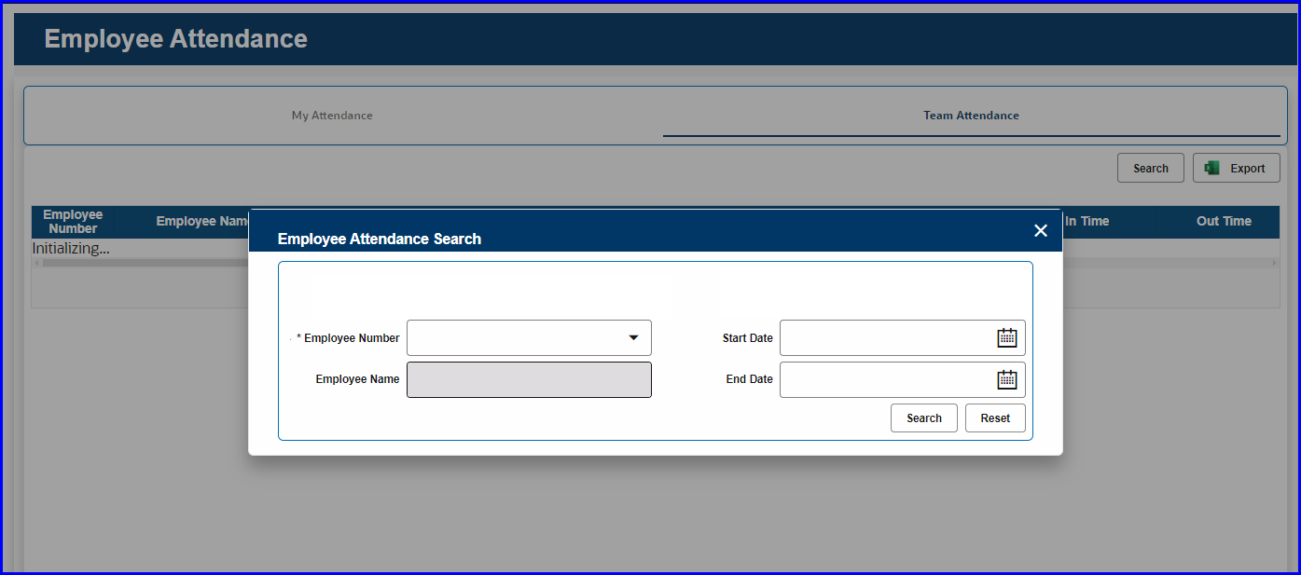
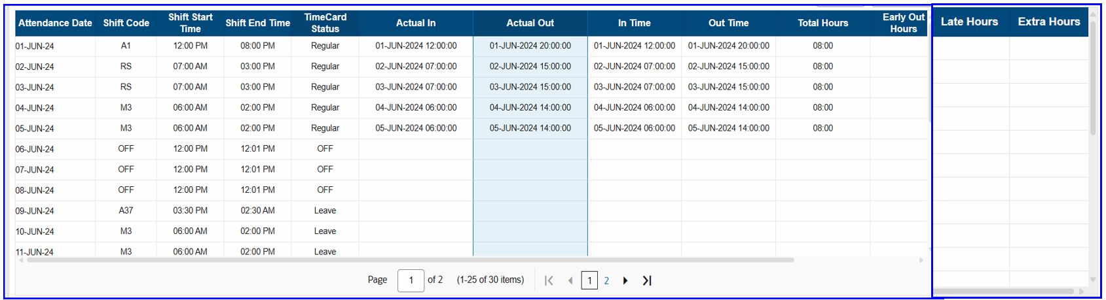
Conditions | Subordinates can be from cross entities as well

HR Attendance
HR will be able to view all employee’s daily attendance details from there login. Below details will be displayed and attendance details will be available to view till previous date.

Below are the Search Option available

- Legal Entity (List based on Area of Responsibility)
- Employee (List should show based on selected Legal Entity)
- Start Date
- End Date

Attendance Date | Displays the attendance date
Shift Code | Displays the Shift code for an particular attendance date that is assigned by Line manager for shift based employee, and regular shift for regular based employee.
Shift Start Time | Displays the Shift Start Time for the assigned shift
Shift End Time | Displays the Shift End Time for the assigned shift
Timecard Status | Displays the Timecard Status as  Regular – If employee does not have any exceptions.  Late/Early – If the employee has Late hours or Missing hours  Absent – If the employee has no punch details for the particular attendance date and not applied leave for that date.  Missing In/Out – If the employee has either Punch In or Punch Out for the attendance Date  Leave – If employee have applied leave for the day  OFF – If the shift is assigned as OFF or if its Friday or Saturday for regular shift employees
Leave Detail | Leave type will be displayed if the approved leave is available
Actual In | Actual In Time displayed, if the employee Punch In earlier than Shift Start Time.
Actual Out | Actual Out Time displayed
In Time | Display the In time of an employee
Out Time | Display the Out time of an employee
Total Hours | Shows total Hours that is calculated between In Time & Out Time.
Early Out Hours | Early out is calculated and displayed, If employee works less than assigned shift hours
Late Hours | Late hours is calculated and displayed, If employee Punch In more than Leverage Min mentioned in Shift
Extra Hours | Extra hours is calculated and displayed, any time employee worked more than the assign shift duration.
Shift Update | HR would have option to change the shift for an employee for a particular date
Reprocess | Button to reprocess employee’s attendance for a selected date

Design
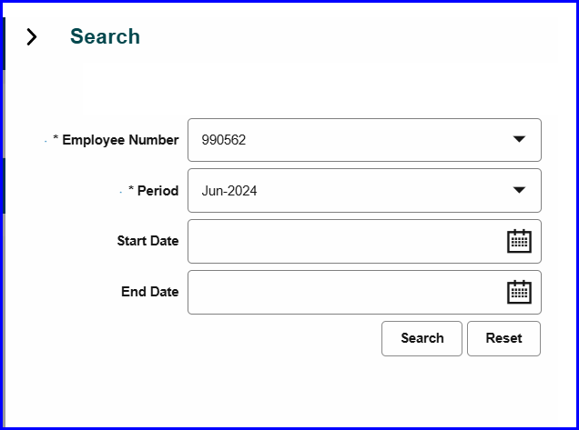
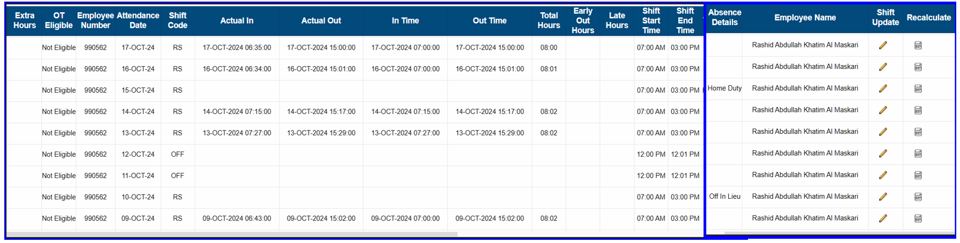
Conditions | Legal Entity should be one of the parameters in search criteria, Because there some HR user who manages more than one entity employees attendance.

Employee Request

Justification
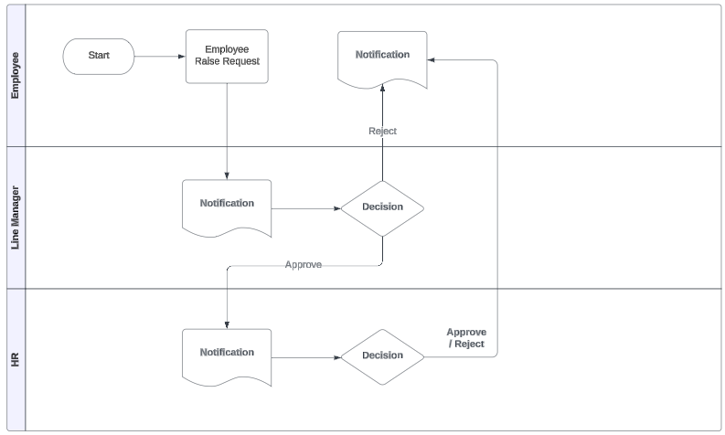
Employee would submit the justification request when employee attendance has Late time or Early Out Time.
Employee must select the justification and remarks, and the request would be forwarded for Line Manager and HR Approval. Below are the details available in the request page.
Return for information option is required.

Design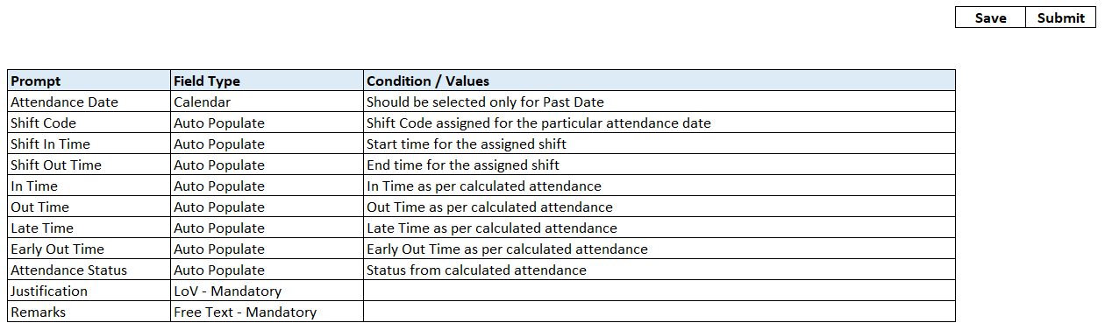

Conditions | Separate page required to set the level of approval for each legal entity
 | HR should have option to submit the request on behalf
 | This request will be enabled only for required Legal Entity

Change Time Request

Employee would submit the change time request when employee attendance status is missing In/Out or Absent.
Employee must select the Reason and enter remarks, and the request would be forwarded for Line Manager and HR Approval. Below are the details available in the request page

Design
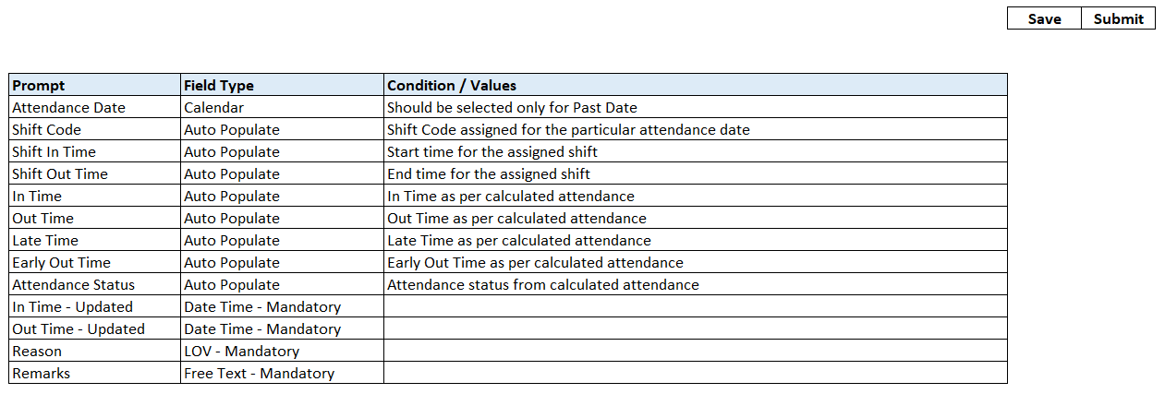

Conditions | Separate page required to set the level of approval for each legal entity
 | Attendance has to be re-calculated based on the In & Out time entered by employee/HR once the request is approved
 | HR should have option to submit the request on behalf
 | This request will be enabled only for required Legal Entity, Example, no change time for OTC

Feeding Hour Request

Employee (Female Only) would submit the feeding hour request.
Employee must select start date and end time, and the request would be forwarded for Line Manager and HR Approval.
Duration between start date and end date should not exceed more than 1 year and start time and end time duration should not exceed 1 Hour per day. Below are the details available in the request page.

Design
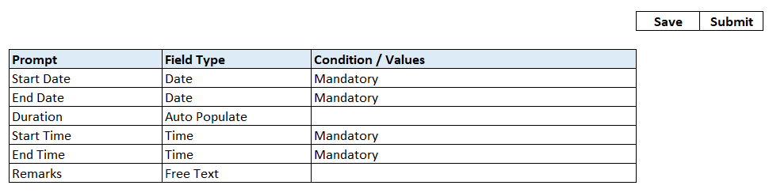

Conditions | Duration should not be more than 1 Year
 | Duration between start time and end time should not be more than 1 Hour
 | Separate page required to set the level of approval for each legal entity
 | Eligible only for female employees
 | This request will be enabled only for required Legal Entity

Overtime Request

Eligibility of Overtime will be captured at employee level, only eligible employee can submit the request.
Employee would submit the overtime request when employee attendance has Extra Hours. System would validate and restrict if the employee is not eligible to submit Overtime.
Employee must select the attendance date and provide reason, and the request would be forwarded for Line Manager and HR Approval. Below are the details available in the request page

Design
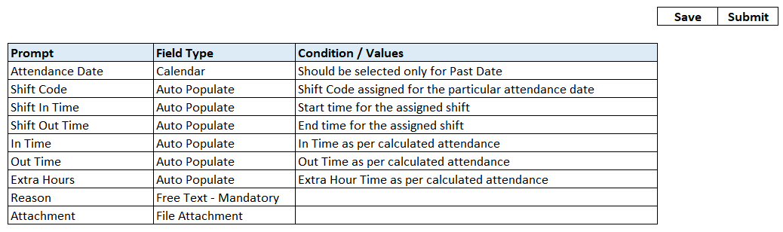

Conditions | Attachment is mandatory for some legal entity only
 | Element has to attached through integration once the request is approved
 | Separate page required to set the level of approval for each legal entity
 | Overtime should be stored based on Day / Night / Weekend at the back end.
 | Only eligible employee shall apply for overtime
 | Some entity do not have Overtime, for those employee, request should not be visible
 | This request will be enabled only for the required Legal entity

Raw Data
Employee and HR would be able to see all the bio metric activity that has been registered and data that is push to Oracle. Employee shall only his data and HR would view the data as per the entity access that he/she has.

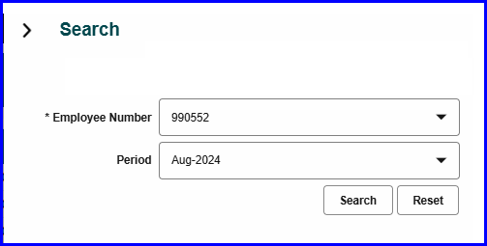
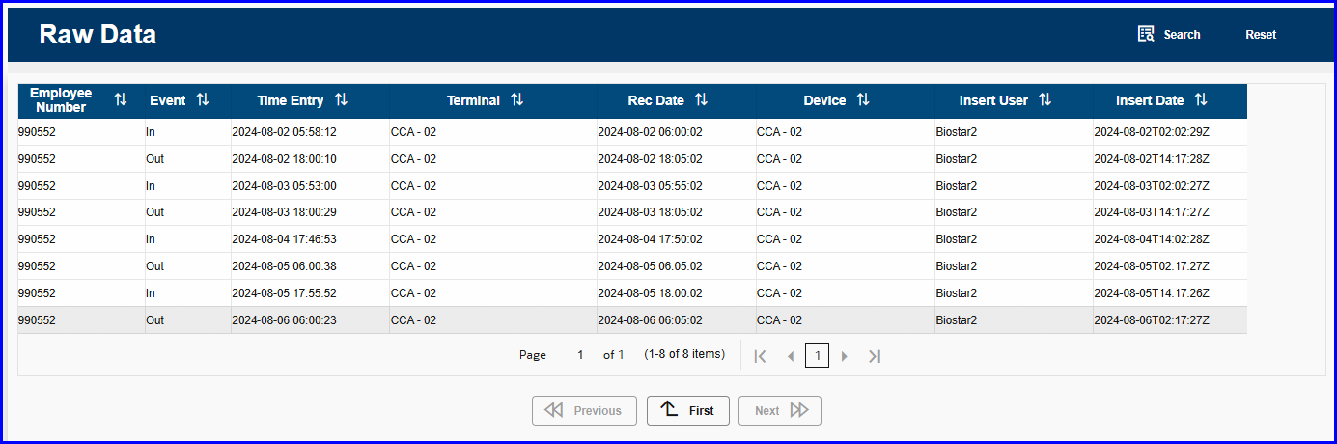

Integration Process
Design
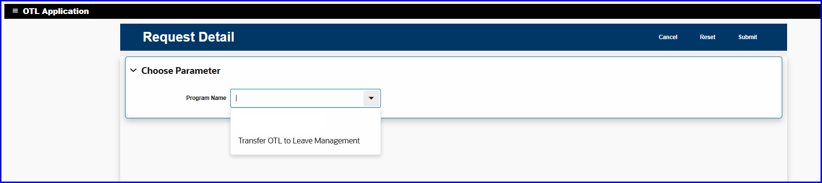
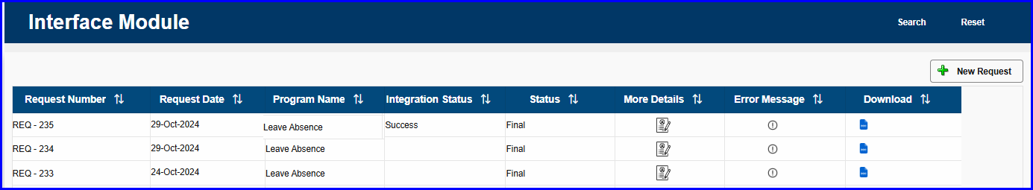

HR would have option to transfer the Absent details to Absence Management module. Below are the details HR must select. Attendance that is marked as Absent will be created as “No Show / Unpaid Leave”

Program
Name | Transfer Absent to Leave Management
Parameters
Employee | Employee list should be restricted based on the access of the HR
Attendance Start Date | Calendar - Mandatory
Attendance End Date | Calendar - Mandatory
Status (Draft / Final) | LOV - Draft - Should generate a Report
 | LOV - Final - Should call the Interface
Integration
Integration should create an Absence by calling the Absence HDL Integration for the attendance that is marked as "Absent" for the duration that is selected by HR

HR will have option to reprocess the attendance for all the employees, in case the attendance data is delay to push to oracle, at this time HR shall reprocess the attendance for all employees or one employee.

Program
Name | Reprocess Attendance
Parameters
Legal Entity | List has to be restricted as per the HR access
Employee | Employee list should be restricted based on the access of the HR
Attendance From Date | Calendar – Mandatory
Attendance To Date | Calendar – Mandatory
Integration
Attendance has to be reprocess for the select attendance Date

Employee Exception
HR shall maintain a list of employees who are excluded from attendance process. Below details has to be entered.
- Employee Number
- Start Date
- End Date

Design
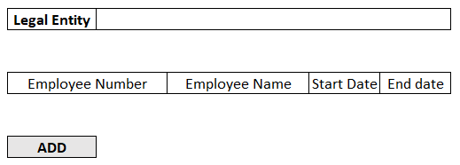

Conditions | Employee mentioned in this list should be excluded from the attendance process
 | Legal Entity list should be restrict based on the HR access

Attendance Exception
HR shall maintain a list of attendance date, system would not calculate exception like late, early out, Absent or Missing In or out for these dates. HR must enter the below details.

- Attendance Date
- Reason

Example for exception days like, Due to weather conditions, Road Traffic or Foreign Diplomate visit in Oman, employee office hours will be reduced.

Design
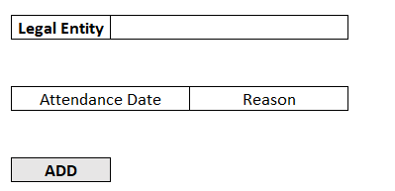

Conditions | Attendance date mentioned here are excluded from exception (late, Early Out, Absent, Missing In or Out
 | Legal Entity list should be restrict based on the HR access

Employee Punch In & Out
Design
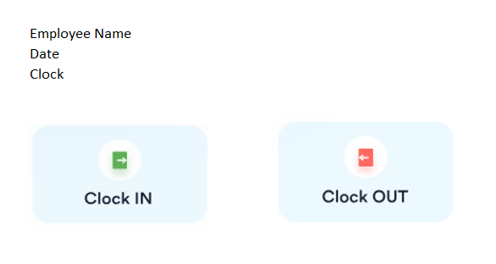

Manager Proxy
Design

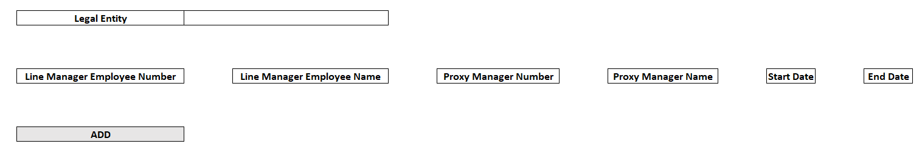

Conditions | Legal Entity list should be restrict based on the HR access
 | Proxy Manager can be cross Legal entity as well

GeoFencing Admin Page

Entity Name
From Location
To Location

Shift Details for Regular Employees
Regular shift employees shift will be captured in the below screen. In some scenario, regular shift employees will work in shift, during that days, shift will be assigned, so shift should be checked first in shift Update, Shift Upload and finally at regular employee shift page.

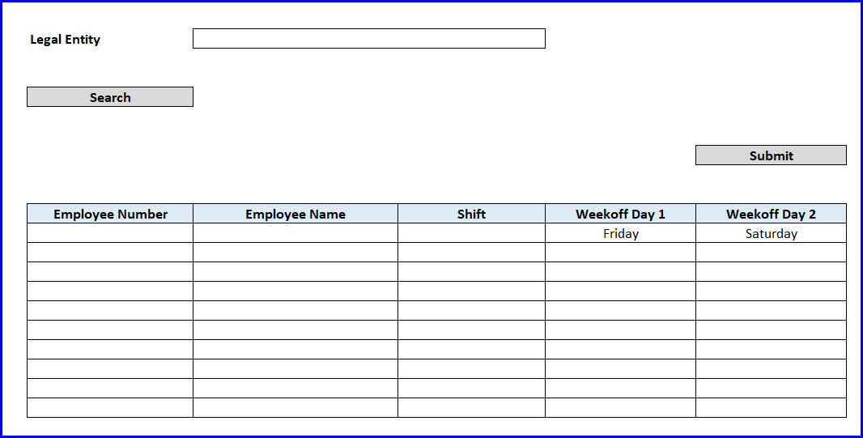
Conditions
Conditions | Employee number should be restricted based on the selected legal entity.
 | Legal entity should be restricted as per the HR Access
 | LOV of shift should be fetched from Shift master as per the legal entity.

Event Request Page - OCEC Entity
Event Manager will raise the request and it should be forward for below approval, once its approved, HR would add the casual staff to the particular request.

Prompt | Field Type | Condition / Values
Event Name | Free text | Mandatory
Event Place | Free text | Mandatory
Event Start Date | Calender | Mandatory
Event End Date | Calender | Mandatory
No of Staff Required | Number | Mandatory
Event Manager | OCEC Employee LOV | Mandatory
Remarks | Free text | Mandatory
Attachment

Approval Hierarchy

Approval
Level 1 | Line Manager
Level 2 | Director
Level 3 | HR
Level 4 | Finance
Level 5 | CEO
Level 6 | HR will add the Resource Details.

Below details are entered against to the request submitted by event manager by the HR once the request is approved by CEO

Prompt | Field Type | Condition / Values
Employee Number | Free text | Mandatory
Employee Name | Free text | Mandatory
Event Start Date | Calender | Mandatory
Event End Date | Calender | Mandatory
Remarks | Free text | Mandatory

Shift Upload – Casual Staff - OCEC Entity
Shift for casual staff can be uploaded by the event manager.




Conditions | Shift can be uploaded for any casual staff (Restrict based on Person Type)
 | HR Can upload shift for any employee (Area of Responsibility) for casual staff

Casual Staff – Time Card Submission - OCEC Entity
Event Manager would select the approved event name and the attendance for these casual staff should be displayed and the he/she would have option to enter the override hour for each attendance date. Once the Event manager submit the request, it has to go for HR approval. Once its approved. Casual staff employee hours has to be transferred to Element Entry. HR would run a process for transfer to payroll.

